1. [**String-1**](https://codingbat.com/python/String-1)**> first_half**

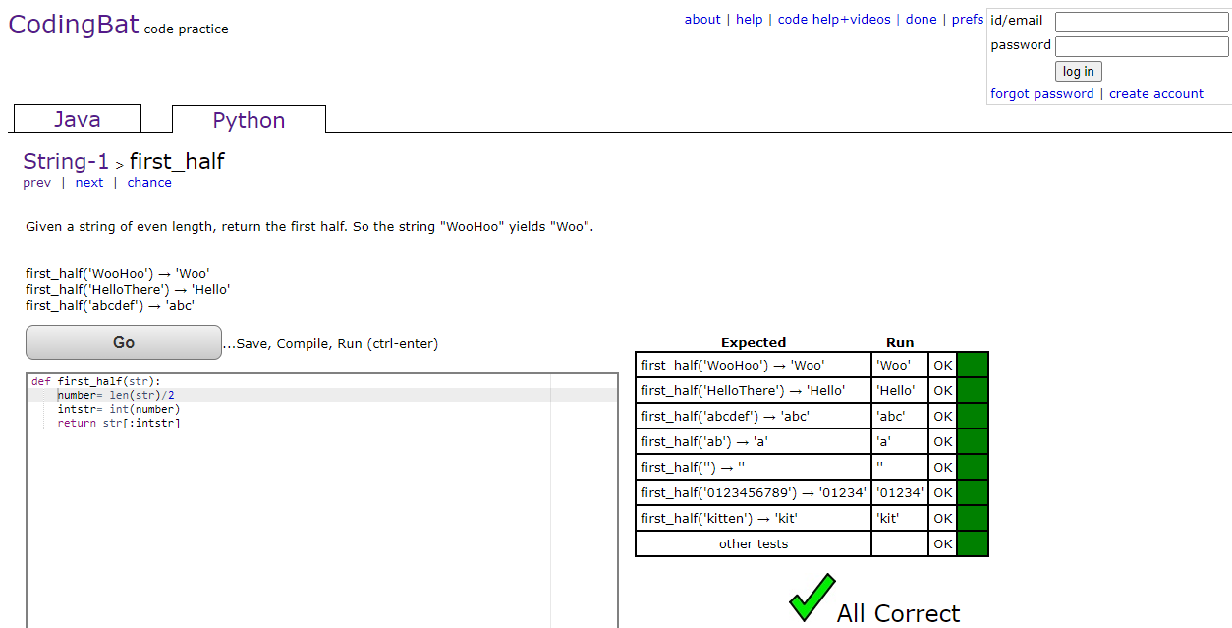

1. [**String-1**](https://codingbat.com/python/String-1)**> without_end**

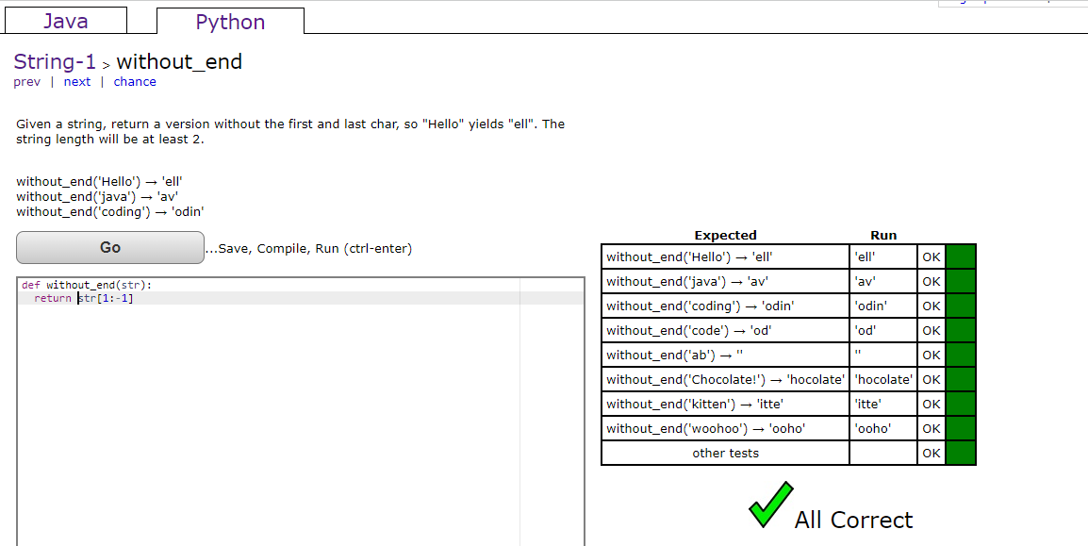

1. [**Logic-1**](https://codingbat.com/python/Logic-1)**> caught_speeding**

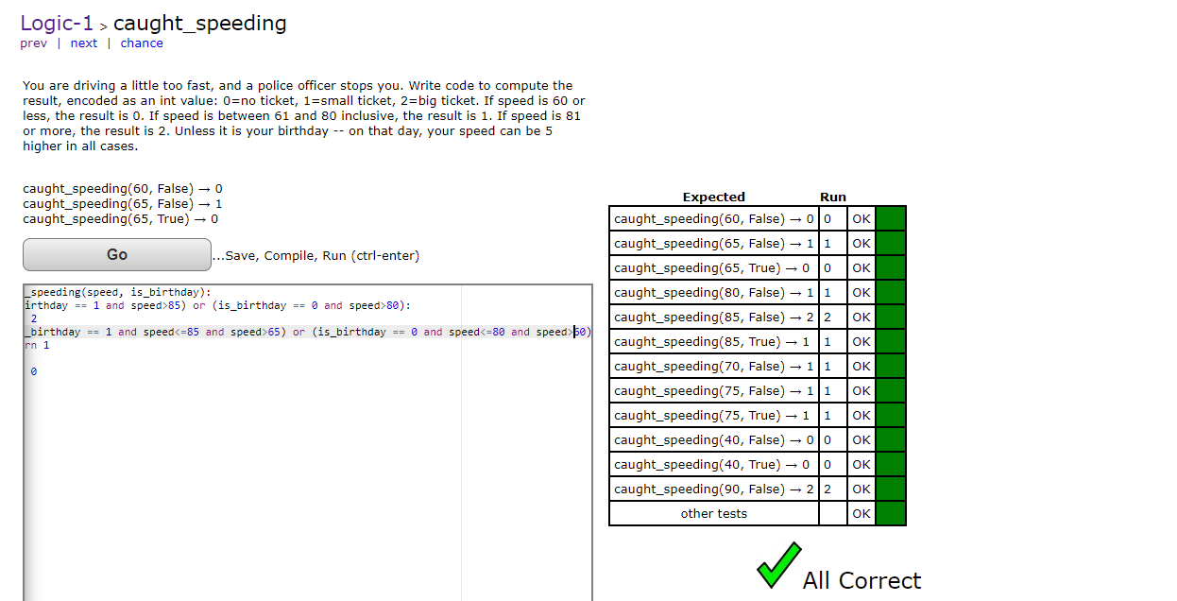

1. [**Logic-1**](https://codingbat.com/python/Logic-1)**> alarm_clock**

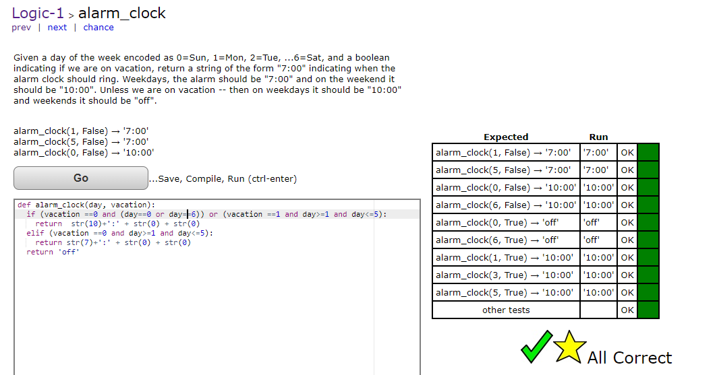

1. [**Logic-1**](https://codingbat.com/python/Logic-1)**> near_ten**

